“ AlgoMentor”

“ AI-Powered Personalized Coding Mentor”

“Team Titans”

“ TechNova Software Hackathon 2026”

“Version 1.0”

Team Members:
1.Karthikeyan M. Roll no;7376242IT193;

2.Girrynaat S. Roll no;7376242IT158;

3.Jaya prakash S. Roll no;7376242IT185;

3.Dayannithi V. Roll no;7376242IT136;

1. Introduction;
AlgoMentor – AI-Powered Personalized Coding Mentor.
The main idea of our project is to help beginner programmers not only fix their coding errors, but also understand why the error happened and learn how to improve their programming skills.
Traditional compilers mainly tell us whether the program is correct or incorrect. But they don't usually explain the mistake in a beginner-friendly way or tell the student what they should learn next.
AlgoMentor solves this problem by combining a coding environment, code execution, AI analysis, and personalized learning resources.

2. Problem Statement;
Beginners commonly face several problems while learning programming.
First, compiler and runtime errors can be difficult to understand.
Second, students may get a correct output but still write inefficient code.
Third, they may not understand time complexity and space complexity.
Finally, after solving one problem, students often don't know what concept they should learn next.
So our objective is to convert coding mistakes into learning opportunities.

3. Proposed Solution;
Our solution is AlgoMentor.
It works like a combination of an online coding platform and an AI programming mentor.
The student writes code, selects a programming language, provides input, and submits it.
Our system executes the code, analyzes the result using AI, reviews the code, explains errors, analyzes complexity, identifies edge cases, suggests improvements, and recommends relevant learning materials.
So our main concept is:
“Don't just fix the code — teach the student.”

4. Complete System Flow;
Explain this diagram slowly:
Student → Frontend → Backend → OneCompiler → OpenRouter → Resource Service → Frontend
First, the student interacts with our frontend.
The frontend is built using React.js.
When the student submits code, the frontend sends the code, language, and input to our FastAPI backend.
The backend sends the code to OneCompiler API for execution.
OneCompiler returns the execution result, such as output, compiler errors, runtime errors, execution time, and memory information.
Then the backend sends the code and execution information to OpenRouter AI.
The AI analyzes the code and produces structured feedback.
Finally, our Resource Service finds appropriate learning resources for the topics identified by the AI.
The backend combines everything into one JSON response and sends it back to the frontend.

5. Frontend Explanation;

“Frontend Technology”
Our frontend is developed using React.js with Vite.
We use Tailwind CSS for styling.
For the coding environment, we use Monaco Editor, which provides a VS Code-like coding experience.
We use Axios for communication with our backend.
Context API and useReducer are used for state management.
Framer Motion is used for smooth UI animations.
React Icons are used for interface icons.

6. Frontend Components
Your frontend contains:

“Header.jsx”
The Header provides AlgoMentor branding, theme controls, and responsive navigation.

“EditorPanel.jsx”
This is the main coding area.
The student can write code, select a language, copy code, paste code, clear the editor, and download the source code.
Supported languages include:
- Python
- Java
- C
- C++
- JavaScript
- Go
- Rust
- Kotlin

Input
The student can provide runtime input through the input section.
For example:
Code:
name = input()
print(name)

Input:
Jaya
The backend receives both the code and input.

OutputPanel.jsx
After execution, this panel displays the program output, compiler errors, runtime errors, execution time, and memory information when available.

AnalysisPanel.jsx
This is where the actual AI mentorship is displayed.
It shows error explanations, debugging suggestions, code review, complexity, optimization, edge cases, and learning resources.

7. Frontend State Management
We use Context API and useReducer to manage global application state.
Important states include:
- User code
- Selected programming language
- Program input
- Loading status
- Execution result
- AI analysis
- Error messages
The flow is:
User Action → Component → Context → Reducer → Updated UI
This prevents different components from managing the same information separately.

8. Frontend to Backend Communication;
The frontend communicates with the backend using REST API and Axios.
The main endpoint is:
POST /analyze
The frontend sends:
{
"code": "student code",
"language": "python",
"stdin": "input"
}
The backend processes this request and returns execution and AI analysis information.

9. Backend Explanation;
Now coming to the backend.
Our backend is developed using Python and FastAPI.
FastAPI acts as the central brain of the application.
It receives the frontend request and coordinates all external services.
We use Pydantic for validating request and response data.
The backend structure contains:
routes/
analyze.py

schemas/
request.py
response.py

services/
onecompiler.py
ai_services.py
resource_service.py

resources/
language resources
DSA resources
algorithm resources
debugging resources

prompts/
analysis.txt

10. Analyze API;
The main backend endpoint is POST /analyze.
This endpoint is responsible for the complete processing pipeline.
When a request arrives, it first validates the input.
Then it calls the OneCompiler service.
After execution, it sends the execution result and source code to the AI service.
Then it calls the Resource Service.
Finally, it creates a unified response.
The complete backend flow is:
Request → Validation → Code Execution → AI Analysis → Resource Mapping → Response

11. OneCompiler Service;
The file onecompiler.py is responsible for communicating with OneCompiler.
We don't execute arbitrary student code directly inside our backend server.
Instead, we use OneCompiler as the external code execution service.
It receives:
- Programming language
- Source code
- Standard input
It returns information such as:
- stdout
- stderr
- compiler output
- execution time
- memory usage
This allows our backend to focus on orchestration and mentorship.

12. OpenRouter AI Service;
After execution, the backend sends the relevant information to OpenRouter.
The AI receives:
- Programming language
- Student's source code
- Compiler output
- Runtime output
- Runtime errors
- Execution time
- Memory usage
The AI then analyzes the student's code.
The important point is:
The AI is not only generating corrected code. It is acting as a programming mentor.

13. AI Analysis;
The AI provides several types of feedback.

Error Explanation
What error occurred?

Why It Happened
Why did the student's code produce this error?

How to Fix
What should the student change?

Code Review
It checks:
- Correctness
- Readability
- Maintainability
- Variable naming
- Best practices

Complexity
It provides:
- Time complexity
- Space complexity

Optimization
It identifies whether the code can be improved.

Edge Cases
It identifies inputs or situations the student may have missed.

Learning Materials
It identifies concepts that the student should learn next.

14. Important AI Rule;
This is a very important point to tell your staff.
Our AI should not randomly recommend advanced concepts.
For example, if a student submits a simple program using only variables, input, and output, the AI should not recommend Graphs, Dynamic Programming, or Binary Search.
Recommendations must be based on the student's actual code and mistakes.
This helps us avoid irrelevant or hallucinated learning recommendations.

15. Resource Service;
After the AI identifies a learning topic, we don't directly allow the AI to generate random learning URLs.
Instead, we have a separate Resource Service.
It contains predefined resources for programming languages, DSA, algorithms, OOP, DBMS, and debugging.
The flow is:
AI Topic → Normalize Topic → Alias Matching → Find Resource → Remove Duplicates → Return Resources
For example:
AI says: dp
↓
Dynamic Programming
↓
Find curated resources
↓
Return learning links
Aliases include:
dp → Dynamic Programming
dfs → Depth First Search
bfs → Breadth First Search
oop → Object Oriented Programming

16. Final Backend Response;
After all processing is complete, the backend creates one unified JSON response.
It contains:
execution
↓
stdout
stderr
time
memory

analysis
↓
error explanation
code review
complexity
optimization
edge cases
learning materials
summary
This structured response makes it easy for the frontend to display the information.

17. Error Handling;
We also designed the backend to handle failures.
For example:
- Missing API keys
- OneCompiler failure
- Compilation errors
- Runtime errors
- Infinite loops
- Execution timeout
- OpenRouter failure
- Invalid AI JSON
If OpenRouter fails, we should still provide the raw execution result from OneCompiler whenever possible.
So one external service failure should not completely break the application.

18. Security;
API keys are stored in environment variables.
Our .env contains:
OPENROUTER_API_KEY
MODEL
ONECOMPILER_API_KEY
ONECOMPILER_API_URL
These keys remain on the backend and are never sent to the frontend.
The backend also validates requests and relies on the external execution service for controlled code execution.

19. Testing;
We test the system with:
- Correct code
- Compilation error
- Runtime error
- Infinite loop
- Wrong logic
- Basic beginner program
We test across languages such as:
- Python
- Java
- C
- C++
- JavaScript
We also test API failures and invalid AI responses.

20. Deployment;
Our backend is designed to be deployed on Render.
The backend starts using:
uvicorn app.main:app --host 0.0.0.0 --port $PORT
The required API keys are configured as environment variables in the deployment platform.

21. Future Scope;
In the future, we can extend AlgoMentor with:
- User authentication
- Coding history
- Progress tracking
- Personalized learning roadmaps
- Saved solutions
- Collaborative coding
- AI chatbot
- Coding contests
- Leaderboards
These are future enhancements, not current MVP features.

22. Final Conclusion;
End your presentation strongly:
To conclude, AlgoMentor is not just an online compiler.
It combines Frontend + Backend + Code Execution + AI + Learning Resources into one platform.
The frontend provides the coding environment.
The backend manages execution and AI services.
OneCompiler executes the student's code.
OpenRouter analyzes the student's code.
The Resource Service provides relevant learning materials.
Finally, the student receives not only a solution, but also an explanation and a learning path.
So our core idea is:
“Code. Understand. Improve. Learn.”
AlgoMentor — Don’t just fix the code, teach the student.:

Output page:
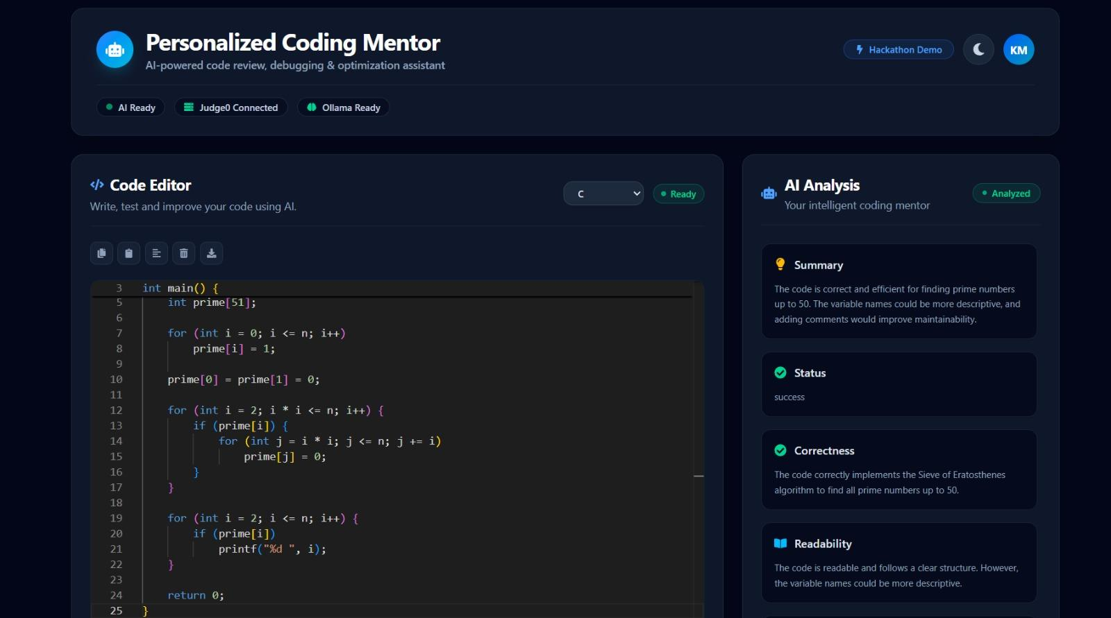
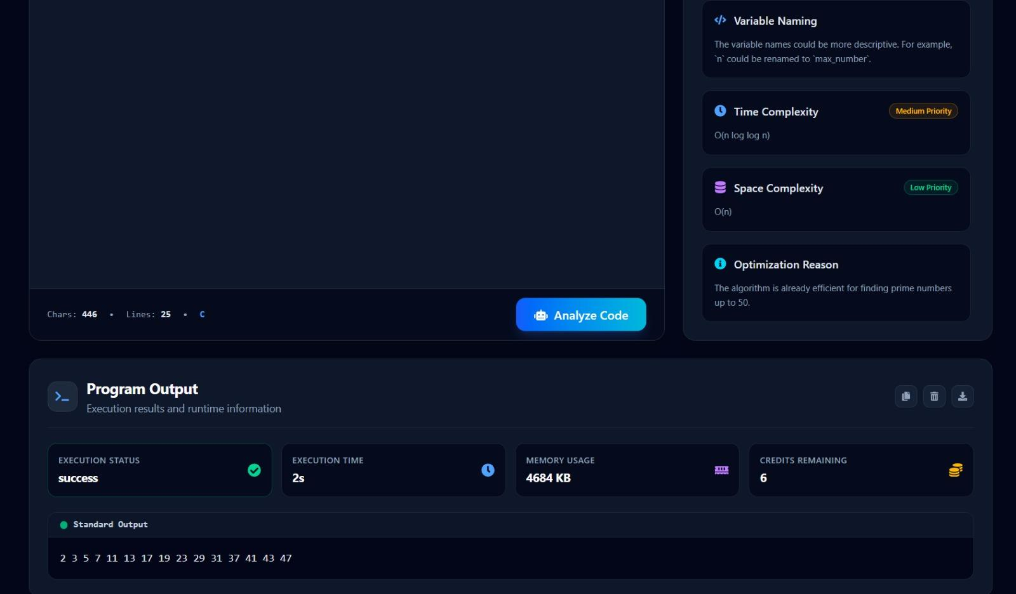

Github.com:
https//github.com/KARTHIKEYAN-M-07/AlgoMentor/tree/main
“Thank you”

